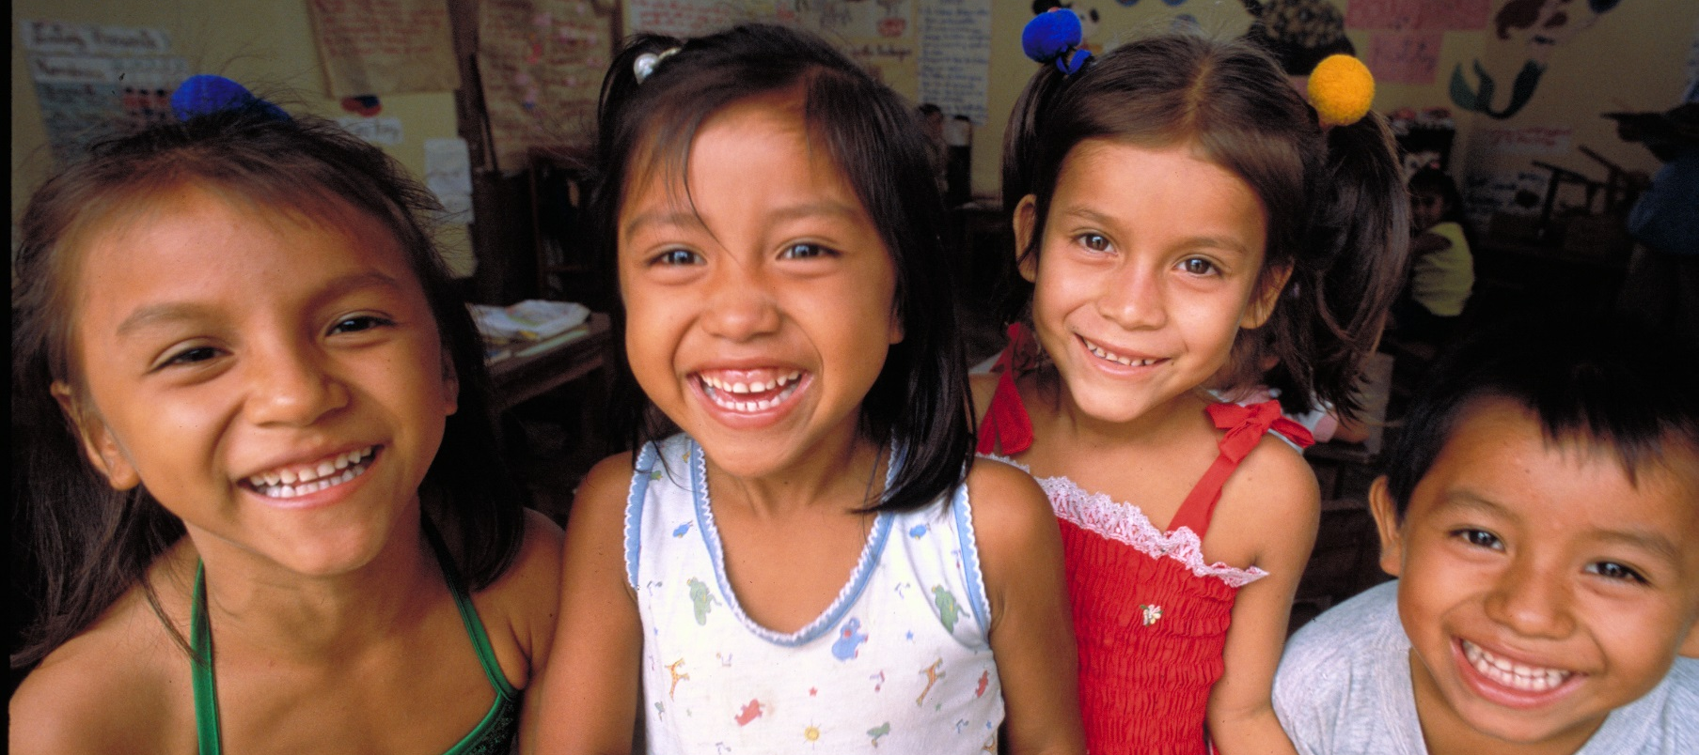

Free Prize Draw Entry Form
Thank you for deciding to host a ShoeShare collection in aid of Unicef! We appreciate your time and dedication to our cause to get children into education across the world. Through Unicef’s partnership with Clarks, we are able to raise funds through our ShoeShare scheme, whereby the public can drop off old or unwanted to shoes to over 500 Clarks stores nationwide.

As a school participating in the Clarks and RRSA initiative, we are offering your school the chance to enter a free prize draw where you could win a £50 Clarks voucher.

To enter, please fill in the details below and return the form to rrsa@unicef.org.uk with the subject heading as “ENTRY - Clarks and RRSA Free Prize Draw”. Closing date to enter and have hosted a ShoeShare collection at your school is 23.59 on Friday 15th September 2017. Winners will be contacted on Wednesday 20th September 2017.
School Name & Address
Contact Name
Contact Number
Contact Email
Clarks Store where shoes were dropped off (if shoes have not yet been dropped off please indicate your nearest Clarks store where you will do so).

For Terms and Conditions, please read here. Any personal data relating to entrants will not be disclosed to a third party without the individual’s/schools consent.

