Student lists - Stage 2 / Re-assessment
Please use this table to send your lead assessor details of the students available to interview during your assessment.
If you are using your own list/template, please ensure all students names are numbered, so that the assessor can let you know the reference number of those selected.

Sending the student lists

Please use the following grids to submit the student lists to the Baby Friendly office so they can be accessed by your assessment team. The list will need to be sent at least two weeks in advance of the assessment

Sending data such as names and contact details should be done securely;
- We strongly recommend you send the files via a secure file sending system and password protect the document. Please avoid sending the lists via email without any encryption.
- You may wish to use the Box upload link to send the file (see guidance below) or your own internal IT department may have a preferred approach or system to use. Allowing plenty of time to research and finalise safe sending of the data will help avoid delay and potential threat to us being able to carry out your assessment effectively.

To send us these files directly, please visit this uploading page on our website
unicef.org.uk/BabyFriendly/Health-Professionals/going-baby-friendly/Health-professionals-contact-us/
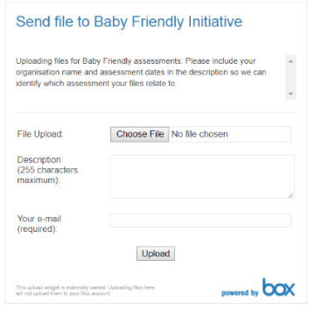
Select ‘choose file’ and select the file you’d like to send from your computer.
Add details in the description box to include your organisation name and dates of assessment.
Add your email address, so we know who has sent the file and who to contact with any queries. You can send additional files by returning to the link again.

If you have password protected the file, please call or email the Baby Friendly office to give the password for the files you’ve sent.
If you are unable to use this uploading page, please send the files by any secure method used by your organisation and ensure the files are password protected
The information provided will only be used in relation to this assessment; we care about keeping your data safe; for more information about Unicef UK’s privacy policy please visit unicef.org.uk/legal/cookies-and-privacy-policy/

Name of your university: |  | Dates of assessment:

Head of Department
Please tell us the name of the head of service

Lecturers
Please tell us the names of all lecturers and their area of responsibility.
If you are unsure who to include, we are looking for lecturers who have input into the programme related to
Baby Friendly learning outcomes
 | Name | Topic area
1
2
3
4
5
6
7
8

Students
Please tell us the names of all students who are on available on the day of the assessment so that we can make a random selection for interview. It is expected that all students are available to take part with the exception of students who are unavailable due to sickness, post night duty. Please tell us their placement hospital/area so that we can select a sample which has a representative spread.
Day 1 of assessment
 | Name | Placement
1
2
3
4
5
6
7
8
9
10
11
12
13
14
15
16
17
18
19
20
21
22
23
24
25
26
27
28
29
30
31
32
33
34
35
36
37
38
39
40
Please add more rows if needed

Day 2 of assessment
 | Name | Placement
1
2
3
4
5
6
7
8
9
10
11
12
13
14
15
16
17
18
19
20
21
22
23
24
25
26
27
28
29
30
31
32
33
34
35
36
37
38
39
40
Please add more rows if needed

