Timetable for student/lecturer interviews – Remote assessment
Please use this table to plan the assessment including the schedule for the interviews. Please submit details of the students available to interview during your assessment two weeks in advance of the assessment. Students should be allocated a 30-minute slot. The Head of Department and Project Lead Lecturer find time in their diary for interview with Assessor 1. 40 minutes should be allowed for these interviews so you may need to amend the timings in the table. Other lecturers will also be interviewed- your assessor will arrange with you who they should be and 30-minute slots should be allocated for these interviews.
We ask that the Baby Friendly project lead lecturer be available throughout the assessment in case of queries.
This format should work for most universities, for smaller or larger student cohorts, this may be adapted if needed following a discussion with one of the Baby Friendly team. Please note – not all slots will be filled, we have provided additional slots to enable some flexibility for appointment bookings.

Video calls for staff interviews / meetings
Once your lead assessor confirms the interview slots on the timetable, you should set up meeting invites for each slot. Please invite all of the assessment team to each interview slot. We suggest also listing their contact details in the grid below.
You will need to check what technology you have access to for video calls, for example Microsoft Teams, Skype for Business or Zoom etc. If you have not set up video calls before please ensure you have plenty of time to check with your IT team. It may also be helpful to set up some practice sessions. It is important to ensure that your video link can be accessed externally by the Baby Friendly assessors.

Sending the timetable

Please use the following grids to submit the timetable to the Baby Friendly office so they can be accessed by your assessment team.
Sending data such as names and contact details should be done securely;
- We strongly recommend you send the files via a secure file sending system and password protect the document. Please avoid sending the lists via email without any encryption.
- You may wish to use the Box upload link to send the file (see guidance below) or your own internal IT department may have a preferred approach or system to use. Allowing plenty of time to research and finalise safe sending of the data will help avoid delay and potential threat to us being able to carry out your assessment effectively.

To send us these files directly, please visit this uploading page on our website
unicef.org.uk/BabyFriendly/Health-Professionals/going-baby-friendly/Health-professionals-contact-us/
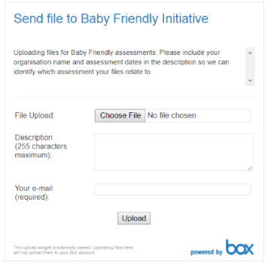
Select ‘choose file’ and select the file you’d like to send from your computer.
Add details in the description box to include your organisation name and dates of assessment.
Add your email address, so we know who has sent the file and who to contact with any queries. You can send additional files by returning to the link again.

If you have password protected the file, please call or email the Baby Friendly office to give the password for the files you’ve sent.
If you are unable to use this uploading page, please send the files by any secure method used by your organisation and ensure the files are password protected
The information provided will only be used in relation to this assessment; we care about keeping your data safe; for more information about Unicef UK’s privacy policy please visit unicef.org.uk/legal/cookies-and-privacy-policy/

Name of your university: |  | Date of assessment:

Assessor 1 |  |  | Assessor 2
Time  Day 1 | Activity  (e.g. student interview, lecturer interview) | Contact name/phone number/email | Time  Day 1 | Activity  (e.g. student interview, lecturer interview) | Contact name/phone number/email
09.00 | Introductory meeting |  | 09.00 | Introductory meeting
09.30 | HOD, Lead lecturer, lecturer interviews |  | 10.00
 |  |  | 10.30
 |  |  | 11.00
11.30 | Break |  | 11.30 | Break
12.00 |  |  | 12.00
12.30 |  |  | 12.30
13.00 | Lunch |  | 13.00 | Lunch
13.30 |  |  | 13.30
14.00 |  |  | 14.00
14.30 |  |  | 14.30
15.00 | Break |  | 15.00 | Break
15.30 |  |  | 15.30
16.00 |  |  | 16.00

Assessor 1 |  |  | Assessor 2
Time  Day 2 | Activity | Contact name/phone number/email | Time  Day 2 | Activity | Contact name/phone number/email
09.00 |  |  | 09.00
09.30 |  |  | 09.30
10.00 |  |  | 10.00
10.30 | Break |  | 10.30 | Break
11.00 |  |  | 11.00
11.30 |  |  | 11.30
12.00 |  |  | 12.00
12.30 |  |  | 12.30
13.00 | Lunch |  | 13.00 | Lunch
13.30 | Scoring |  | 13.30 | Scoring
14.00 | Assessor discussion |  | 14.00 | Assessor discussion
15.00 | Discussion with Lead Lecturer |  | 15.00 | Discussion with Lead Lecturer
15.30 | Feedback |  | 15.30 | Feedback
16.00 | Close |  | 16.00 | Close

