Unicef UK Baby Friendly Initiative
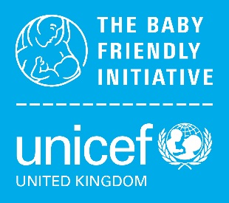
Slide pack for dietitians request form

Please use the boxes below to request a copy of the Unicef UK Baby Friendly Initiative’s Slide pack for dietitians.

Return this form by email to bfi@unicef.org.uk. We will then send the presentation package to you via email.

University and Programme name:
Does your university run other health programmes where infant feeding teaching is required? (delete as applicable) |  | Midwifery / Health Visiting / Children’s Nursing / Medicine
If not working at a university, please provide organisation details:
Service name, and details of who you intend to train using these materials
Staff member taking responsibility for delivering the presentation:
Name: |  | Job title:
Email:
Date: |  | Signed:
We care about keeping your data safe; for more information about Unicef UK’s privacy policy please visit unicef.org.uk/legal/cookies-and-privacy-policy/

