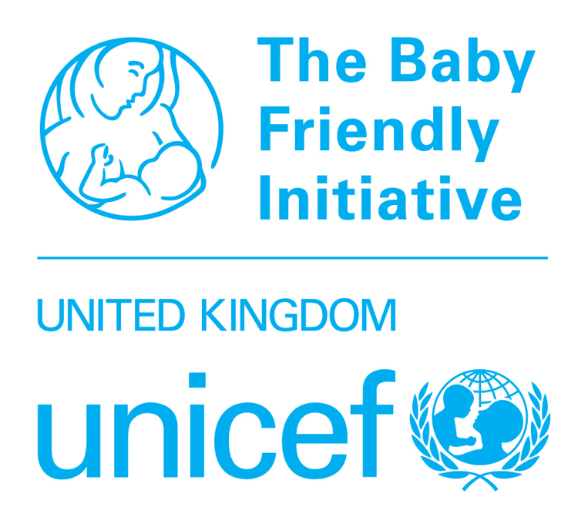
POSTER SUBMISSION FORM
UK Committee for UNICEF (UNICEF UK)
Baby Friendly Initiative 2025 Annual Conference

12-13 November 2025

This form should be submitted by email only to bfi@unicef.org.uk by midnight on Sunday 15 June 2025 with the subject line 2025 Conference Poster Submission. All fields on this form must be completed.

Submission requirements
- Your name, organisation and contact details
- Poster title
- Poster description of no more than 200 words (not including the title or contact details)
- Submit your poster description via this form by 5pm on Friday 6th June 2025
Additional information
- Poster descriptions will be reviewed by a panel and successful posters will be confirmed by email
- Results will be communicated in the week commencing 14th July 2025
- If successful, at least one person is required to register for the conference and pay the associated fee and bring your poster to the event; places can be booked here
- Delegates must produce, bring and display their own posters on arrival at the venue, and are responsible for collecting their posters at the end of the conference
- Numbered poster boards and hook and loop tape will be provided by Baby Friendly at the venue
- Posters should be printed in portrait format only, size A0 is recommended
- Submissions can be made jointly; however we require one name and email address for the point of contact
- Successful posters will be displayed in print at the conference and electronically on the Baby Friendly website after the conference.
- Further guidance and information will be sent to successful poster presenters
Contact details
Primary contact name:
Additional names (if applicable):
Organisation:
Email:
Telephone:
Poster details
Poster title:
Description of proposed poster content (maximum 200 words)

Submitting authors will be sent an acknowledgement email to confirm that their poster description has been received. If you do not receive a confirmation email, please follow up to ensure that your submission has been received. Successful submissions will be confirmed to the email address provided.
The information provided on this form will only be used in relation to this event. We care about keeping your data safe; for more information about UNICEF UK’s privacy policy please visit unicef.org.uk/legal/cookies-and-privacy-policy/

