
Printed resources order form 15.01.2026
Please complete and return by email only to bfi@unicef.org.uk

How to order
Complete all sections of this form and return with payment details/copy of purchase order.

Please note we cannot process your form until sufficient payment details (e.g. a copy of a PO) are received. Orders for UK delivery only and include postage and packaging costs, but this is to one address only. Orders are processed weekly and once all documents are received they may take up to 7 working days to process. The Baby Friendly Initiative reserve the right to re-print items at any time. If you are looking to order audit tools or e-learning please use our digital resources order form.
We care about keeping your data safe; for more information about UNICEF UK’s privacy policy please visit unicef.org.uk/legal/cookies-and-privacy-policy/
Contact details |  |  | Delivery details*
Name: |  |  | Name/FAO:
Organisation: |  |  | Full address:
Telephone: |  |  | Full address:
Email: |  |  | Postcode:
*Please note if you choose to pay by invoice, the delivery address will be taken from the official purchase order – please ensure the PO quotes the delivery address you require

Order total: | £ | Please complete the grid overleaf for item quantities and pricing
Payment Please select your chosen payment method and provide the relevant information
 | By card – please call 0300 003 0877 to place your order by telephone directly with our fulfilment company Elovate.
By invoice – please send a copy of the official purchase order document with this form. Orders cannot be processed until this is received.
Purchase order number: (copy of PO is also required)
By banked funds – please specify details of the funds held with us
Name of organisation: Details of funds held:
Printed resources For further information please see www.unicef.org.uk/babyfriendly/resources
Item |  | Code | Quantity | Unit price | VAT | Total price
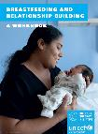 | Breastfeeding and relationship building: a workbook (1-9 copies) | BRBW23 |  | £17 | zero
 | Breastfeeding and relationship building: a workbook (more than 10 copies – discount) | BRBW23-B |  | £11 | zero
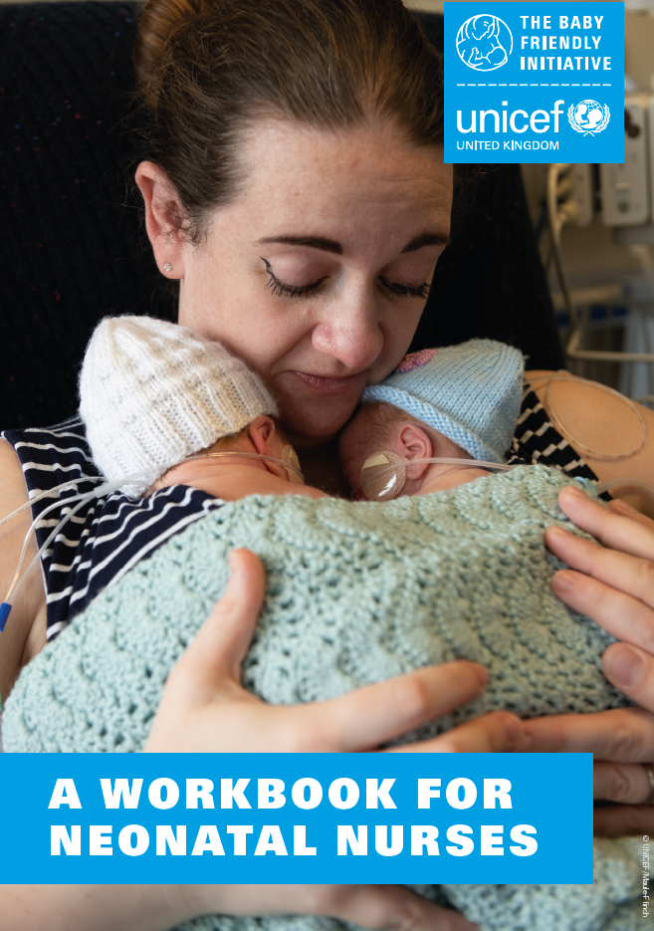 | A workbook for neonatal nurses (1-9 copies) | NNUW23 |  | £17 | zero
 | A workbook for neonatal nurses  (more than 10 copies – discount) | NNUW23-B |  | £11 | zero
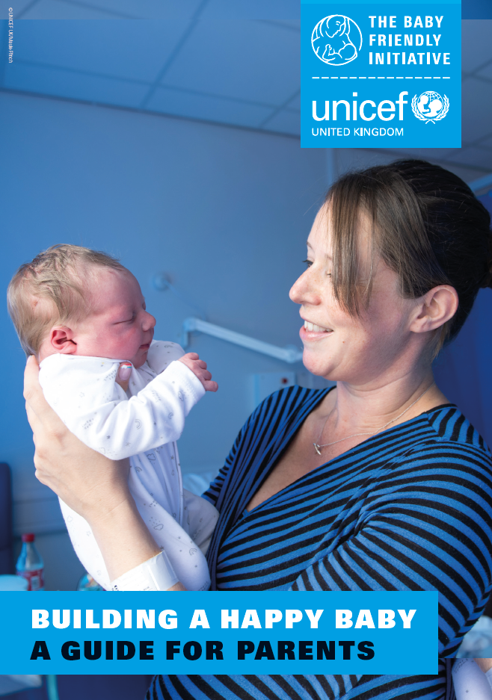 | Building a happy baby: A guide for parents leaflet (50 copies per pack) (1-9 packs) | BHBL24 | packs | £16 | zero
 | Building a happy baby: A guide for parents leaflet (50 copies per pack)  (over 10 packs – discount) | BHBL24-B | packs | £12 | zero
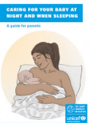 | Caring for your baby at night and when sleeping leaflet  (50 copies per pack) (1-9 packs) | CBNL25 | packs | £16 | zero
 | Caring for your baby at night and when sleeping leaflet  (50 copies per pack) (over 10 packs – discount) | CBNL25-B | packs | £12 | zero
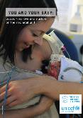 | You and your baby: Supporting love and nurture on the neonatal unit  (50 copies per pack) (1-9 packs) | NNUL21 | packs | £16 | zero
 | You and your baby: Supporting love and nurture on the neonatal unit  (50 copies per pack) (over 10 packs discount) | NNUL21-B | packs | £12 | zero
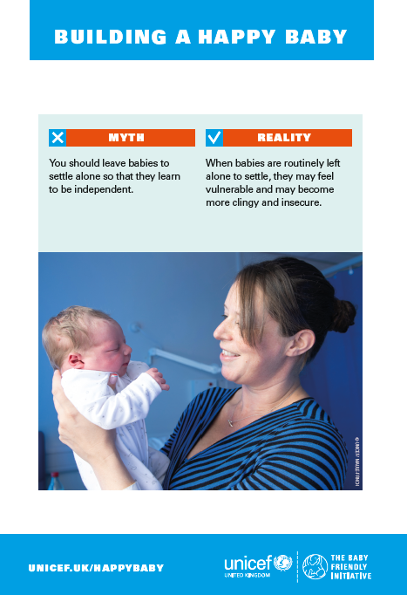 | Mythbusting posters (set of four A3) | MBP24 |  | £15 + VAT = £18
Total:

