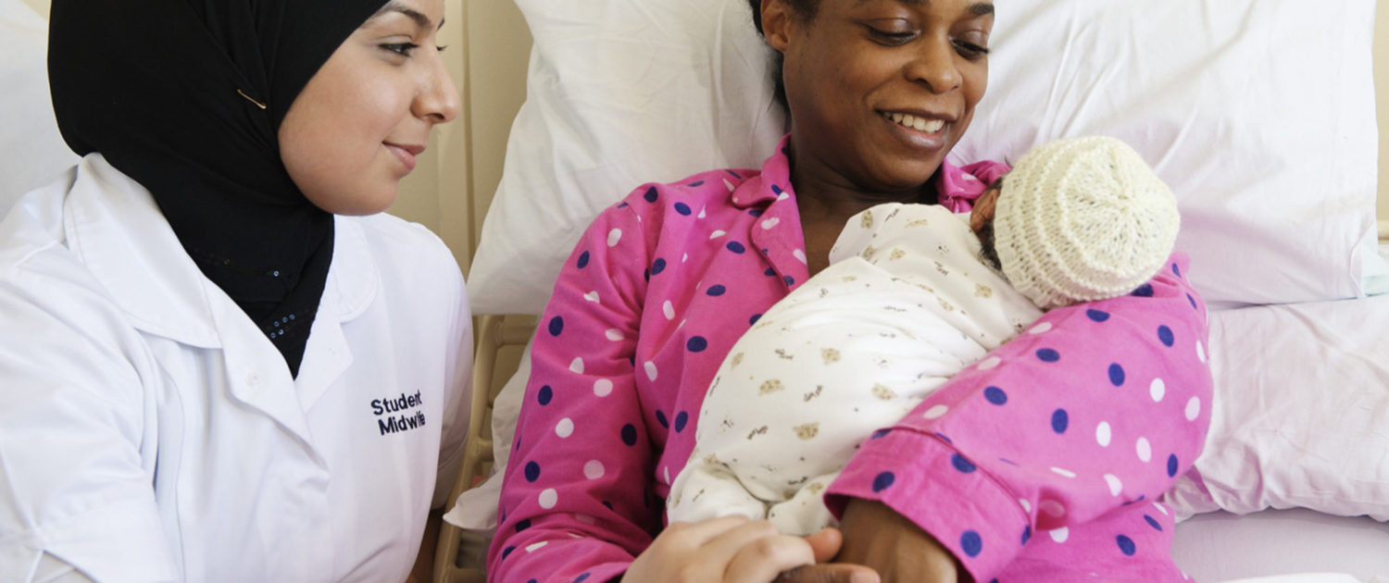
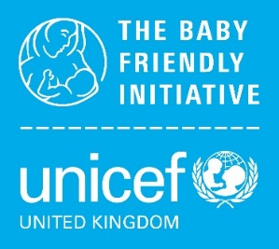
©UNICEF UK/Mead

Unicef uk baby friendly initiative infosheet

SHOULD WE GO FOR the gold award?

A GUIDE FOR UNIVERSITIES PREPARING FOR RE-ASSESSMENT

What is the Gold Award?
In 2016 the UK Committee for UNICEF (UNICEF UK) launched new Achieving Sustainability standards. Universities that are currently accredited as Baby Friendly will be eligible to be assessed against these standards at their next scheduled re-assessment. If the university meets all of the criteria, the relevant department will be accredited as Gold Baby Friendly. It is suggested that you read the Achieving Sustainability standards and guidance document carefully before considering the information in this infosheet.

Which universities are eligible to go for Gold?
Universities that are fully accredited as Baby Friendly can consider going for Gold. The Award is designed as the next step for accredited universities whose audit results consistently show that the Baby Friendly standards are largely being met. The Gold assessment can be carried out following the next planned re-assessment. Unlike the initial accreditation, the Gold Award will be made to the midwifery or health visiting department (or equivalent public health nursing courses in Wales, Scotland and Northern Ireland) rather than just the programme.

Do all accredited Baby Friendly universities have to go for Gold?
It is not compulsory to go for Gold. The decision is entirely up to the individual university and choosing not to go for Gold will not affect accreditation. There is also no time limit for going for the Award. If a university does not feel that they are in a position to go for the Gold Award at the time of their re-assessment, they will still be eligible to go for the Award at their subsequent re-assessment.
Universities that are not yet fully accredited or that are accredited but are still working to achieve consistency will be encouraged to use the Achieving Sustainability standards to support their work to fully embed the standards over time. Once this has been achieved, they can then consider going for Gold. A university is considered to be Achieving Sustainability when they have implemented and maintained the core Baby Friendly standards and learning outcomes for at least three years as confirmed by a full re-assessment. In addition, they have the adequate leadership structures in place to support continued maintenance of the learning outcomes and for progressing and improving the standards and learning outcomes over time.

What is the advantage of achieving the Gold Award?
Working towards the Gold Award acts as an incentive for universities to properly embed the Achieving Sustainability standards and so consolidate and protect all the hard work that has gone into achieving Baby Friendly accreditation. This will mean that future generations of babies, their mothers and families will continue to experience Baby Friendly standards of care. The Award will be a recognition that the university is not only implementing the Baby Friendly Initiative standards, but that they also have the leadership, culture and systems to maintain this over the long term.
Gold university departments will no longer have to undergo large external re-assessments in order to maintain their accreditation, but rather will be re-validated via the annual submission of a portfolio (see page 3) and three-yearly re-validation meetings with an external assessor. Re-assessment costs will be replaced with an annual licence fee.

What do we need to consider before deciding whether to go for Gold?
Prior to your next re-assessment, it is suggested that the decision about whether to go for the Gold Award is taken by a mixed group of staff, including key lecturers, senior staff and the Baby Friendly Guardian. This will bring a range of perspectives to the analysis of whether the university is ready or not. This group will need to consider the internal audit results of the core Baby Friendly standards. They will then need to complete the Achieving Sustainability self-assessment tool (see appendix) and identify which criteria are currently being met, which criteria will need more work, and how long this will take.

The university is ready to go for Gold when:
- Internal audit results indicate that most of the core Baby Friendly standards will be met at re-assessment
- The Achieving Sustainability criteria as listed on the self-assessment tool (see appendix) are being met or can be achieved within a reasonable timeframe of the re-assessment
- Key staff have undergone managers’ education
- A Baby Friendly Guardian is in post and has undergone relevant education according to need.

How does the assessment for the Gold Award work?
- When completing the re-assessment application form, the university indicates that they would like to go for the Gold Award.
- The planned re-assessment is then slightly amended, and the assessors carry out more in-depth interviews with key members of staff. This extra information gathered has no bearing on the re-assessment, which will be carried out and judged as normal. Instead, the information is stored and will be used as part of the Gold assessment.
- Following a successful re-assessment:
- the university applies for an Achieving Sustainability (Gold) assessment which will be carried out remotely by one assessor over one day (similar to Stage 1 assessment)
- unless the re-assessment has happened within the preceding few months, a cohort of students will be interviewed to ensure core Baby Friendly standards have been maintained. Student audits will also be submitted to demonstrate continued high levels of knowledge and skill
- the university completes an application form and submits this, along with all supporting material, to the nominated assessor at least one week before the assessment.
- On the day of the assessment, the assessor will review the application form, supporting material and results of the staff and student interviews. The assessor will then interview key members of staff including the head of Department, Guardian and Project Lead Lecturer via telephone or video call about the findings. A date for this to happen will be arranged with you.
- A report will be written and submitted to the Designation Committee for their decision. The report will also be sent to the university being assessed.
- If there is evidence that all the Achieving Sustainability standards are met, then the university will be accredited as Gold. If some of the standards are not met, then more time will be given to make the necessary changes and submit further evidence of the improvements made. This may or may not necessitate a further charge, depending on the amount of time needed to review the additional materials.

What happens once we have the Gold Award?
- A portfolio will be kept by the university which will include audit results and other relevant data. It will also record successes and challenges relating to all the standards, including evidence of action planning and evaluation. Significant changes in management structures and personnel will also be reported.
- A revalidation meeting will take place, online, two years after the initial receipt of the Gold Award, with key staff, including the Baby Friendly Project Lead, Head of Department and Guardian and a UNICEF UK Baby Friendly Initiative assessor. This provides an opportunity, to review the portfolio and the actions taken to address any recommendations made at the Gold assessment.
- Further formal re-validation meetings and presentations will take place with a Baby Friendly Initiative assessor at four years and then every subsequent three years.
- If significant changes have been made to the curriculum since the initial Gold award was made a sub-set of students may also be interviewed.
- In the interim years, an annual report with key documents from the portfolio will be submitted to UNICEF UK. Additional documents and information can be requested to aid clarification if needed.
- Short notice monitoring visits will be carried out by UNICEF UK on a percentage of universities holding a Gold Award every year.

Further questions
What happens if we decide to go for Gold, but don’t pass the re-assessment?
This will depend on how many requirements and recommendations are made following the re-assessment. If there are a limited number and overall the result is good, then you will be asked to do the necessary work to make improvements and then submit internal audit results or undergo a follow up. Providing the results of these are satisfactory, the university will then move on to the Gold assessment.

However, if there are significant improvements required, then the university may be asked to undergo a further re-assessment before moving forward to Gold. The ultimate decision will rest with the Designation Committee.

What happens if we don’t pass the Achieving Sustainability assessment?
This will depend on which criteria the university has not passed, and how many require improvement. A likely scenario is that the university will be asked to make the necessary improvements and then submit further evidence that these improvements have been made by a specified date. The assessor will consider the evidence and submit the findings to the Designation Committee who will make the accreditation or ask for more evidence if required.

We have recently passed our re-assessment. Can we go for Gold?
Yes, providing you believe you can meet the criteria listed in the Achieving Sustainability self-assessment tool (see appendix). It may be that a bespoke package needs to be arranged for your university to allow UNICEF UK to gather all the relevant evidence needed to confirm that you are implementing all the core Baby Friendly Initiative standards. Contact the office for more details.

What happens if we decide not to go for Gold?
If the university decides not to go for the Gold Award at this re-assessment, they can consider it again at the next re-assessment. The timing and structure of the next re-assessment can be discussed with the Baby Friendly team on an individual basis. There is no rush or pressure to go for Gold if your university is not ready; we will support you to move forward in any way that supports the university to deliver the best outcomes for babies, their mothers and families.

Achieving Sustainability self-assessment tool for universities

Please refer to the Achieving Sustainability guidance document for details of the evidence required for each criteria at the Gold Award assessment. This self-assessment tool is designed to support you to decide if you are ready for a Gold assessment. Please work through the checklist below deciding if you feel each criteria is met. Only tick ‘met’ when you believe that all the evidence required is available. Once you have completed the checklist and all standards appear to be met, please email it to bfi@unicef.org.uk so we can decide on a Gold assessment date with you.

University details
University name
Contact name, email & telephone
Re-assessment date
Please indicate when you would be ready to have a Gold assessment (e.g. month)

Themes, Standards and criteria | Met / partially met / not met | Action required
Theme 1: Leadership
- There is a named Baby Friendly project lead lecturer/team with sufficient knowledge, skills and hours to meet their objectives
- Baby Friendly education would be maintained if the current lead was no longer in post
- The role is achievable within routinely worked hours without the need for routine overtime – paid or unpaid
- Succession planning has been considered.
- There is a mechanism for the Baby Friendly project lead lecturer / team to remain up-to-date with their education and skills
- The lead/team are enabled to attend NIFN meetings, Baby Friendly Annual Conference etc.
- A Baby Friendly Guardian with sufficient seniority and engagement is in post
- The Guardian is a high-level member of staff with faculty influence
- The Guardian can demonstrate engagement via examples of where they have been able to influence decisions or actions in the university.
- The leadership structures support proportionate responsibility and accountability
- There is a formal leadership structure such as a strategy group or similar, or Baby Friendly is a formal agenda item of Department meetings and the Programme Committee
- This group receives reports related to audit and assessment results, evaluations etc, agrees actions and ensures these are delivered
- All relevant SLT members are engaged and aware of roles and responsibilities.
- All relevant managers are educated to support the maintenance of the standards
- All relevant SLT members, including the Guardian, have received specific training to enable them to understand Baby Friendly and the wider social and political context.
Theme 2: Monitoring
1. Baby Friendly audits are carried out regularly according to university needs
- There is a structured plan for conducting audits
- The audit plan is responsive to need and this can be demonstrated
- Staff are trained and able to carry out audits
- Data is analysed effectively and collectively to give an overall picture
- Audit and assessment results are analysed to identify gaps in teaching, learning and assessment and considered by the leadership team regularly
- Consideration is given to evaluation and student feedback and this can be demonstrated
- Action plans are developed in response to findings
- Action plans related to maintaining learning outcomes are developed according to need
- Action plans to aid progression have been developed in response to relevant data or changing evidence base.
- Relevant data is routinely reported to the leadership team
- A mechanism for reporting e.g. a standard report template, dashboard or other mechanism is used to ensure that all data is reported
- Examples are available to be submitted.
- Relevant data is routinely reported to UNICEF UK
- Annual audits have been submitted routinely to UNICEF UK
- Any audits required following recent re-assessment or annual audits if relevant are available and ready to be submitted.
Theme 3: Progression
1. The university demonstrates innovation and progress
- Examples of developments made to enhance teaching learning and/or assessment can be evidenced and submitted
- Examples of developments made to enhance outcomes for students or staff or to widen the impact of Baby Friendly into other departments within the university
- Developments have been planned/made based on audit and assessment results, feedback from students and/or emerging evidence and have the potential to improve delivery of the learning outcomes
- The rationale for the development, and details of planning, implementation and evaluation are clear and can be explained in the submission
- Any other innovations that you would like to showcase are available to be submitted for consideration e.g. research articles.

Please note that significant changes in the university such as a major reorganisation, changes to the commissioning process or changes in key staff members can have a significant impact on the ability of the university to meet these standards, in particularly Leadership, so you are advised to consider very carefully whether you apply for a Gold assessment at such times or shortly afterwards.

