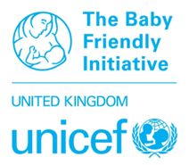
Guidance notes
Stage 2 assessment – Neonatal
June 2026 onwards

Introduction
Stage 2 of the Baby Friendly Initiative assessment procedure is designed to assess the level of knowledge and skills, related to the standards, of the staff who are caring for babies and their parents. A satisfactory overall level of knowledge and skills is required if the Baby Friendly standards are to be implemented effectively.

An educated workforce
- Educate staff to implement the standards according to their role and the service provided.
You will be ready for Stage 2 assessment when at least 80% of your staff have completed the training programme and when audit results give a good indication that, by the date you think you will be ready, at least 80% of the staff will be able to demonstrate the necessary knowledge and skills (see Section 2 of this guidance). Using the UNICEF UK audit tool throughout the time when you are working towards assessment at both Stages 2 and 3, will help you to monitor your progress, judge when you are ready to be assessed and minimise the chances of a disappointing outcome at the assessment. It will also enable you to complete the application form easily.

When you are planning for Stage 2 assessment, please contact the Baby Friendly Initiative office to discuss the preparations to be made and to arrange an assessment date. This is likely to be several months ahead and we will ask for the Stage 2 application form at least three months before the agreed date for the assessment. This is to allow for consideration of the audit results and discussion with you about whether and how any outstanding issues can be addressed within the timescale. After this discussion, you may feel that you would rather re-schedule the date of the assessment and we will be able to postpone without financial penalty, provided that you have submitted the application form at least three months in advance. Any applications received later than this may incur costs should a decision be made to postpone.

: Please read this guidance document in conjunction with the Stage 2 assessment application form.

Combining Stage 2 with Stage 3 or a maternity assessment
It may be possible to combine the Stage 2 assessment with either Stage 3 for the neonatal unit or with a maternity assessment in order to achieve some cost saving. Please discuss your needs with the Baby Friendly office prior to scheduling the assessment.

We care about keeping your data safe; for more information about UNICEF UK’s privacy policy please visit unicef.org.uk/legal/cookies-and-privacy-policy/

The UK Committee for UNICEF (UNICEF UK) Baby Friendly Initiative fully supports inclusivity in accordance with Article 2 (non-discrimination) of the UN Convention of the Rights of the Child and the Equality Act 2010. Learn more about our inclusivity policy at: unicef.uk/bf-inclusivity

Transition to the revised standards
Some aspects of standards required for Stage 1 assessment ‘Building a Firm Foundation’ were enhanced and termed the Foundation Standards. For assessments June 2026 onwards, these will now be fully required.
Foundation standards
- A strategy group
- A Guardian
- Data sharing – pregnancies and new births
- Hand over from acute services
- Training – annual updates for all, training for commissioned service workers
- Consideration of population needs
- Co-design of services

Further information:
unicef.org.uk/babyfriendly/foundation-standards-factsheet/
Understanding the requirements
Throughout this document, we refer to each piece of evidence as being either required or recommended.
- When a piece of evidence is said to be required this means that it forms part of the Baby Friendly Initiative standards and is therefore necessary in order for the unit to be accredited as Baby Friendly. If a piece of evidence identified as a requirement is not submitted, then we will be unable to award a pass at Stage 1.
- When a piece of evidence or a certain action is recommended this means that we believe it to be an effective way of making sure that the standards are implemented and therefore the Baby Friendly Initiative recommends that this is what is done.

As an example:
The standards state that all health care staff must be trained to support a mother to express her breastmilk for her baby. An acceptable overall level of ability to do this amongst staff interviewed is therefore required. Experience has shown that the most effective way to achieve this is for all relevant staff to undergo practical training in the necessary skills. The Baby Friendly Initiative therefore recommends that Practical Skills Reviews be included as part of the mandatory staff education programme.

Background information required prior to Stage 2 assessment
We need you to supply us with certain pieces of information to help us to plan the assessment. This includes demographic, birth and infant feeding data. We will send an email to ask for this information (or an update to the information we previously have on file). A prompt response would be appreciated as the details will help us to organise the assessment.

Documentary evidence required at a Stage 2 assessment
The policy, staff training curricula and mechanisms for ensuring attendance at training and for auditing practice were assessed at Stage 1. We may review any or all of these in the light of practice found at the Stage 2 assessment. Please submit these two weeks in advance of the assessment. We will also need to review staff training records – we will aim to do this during the assessment using a shared screen

: For full details please refer to the Guidance for neonatal units

Section 1 – The standards for staff education
Listed below are the standards which will be assessed at Stage 2.
Standard  Staff… | This applies to… | How assessed? | Minimum % required to pass
1. Have been orientated to the policy | Staff who have been employed for ≥ 1 week | Via records | 80%
2. Have completed the mandatory training programme and Practical Skills Review | Staff who have been employed for ≥ 6 months | Via records &  by interview | 80%
- Can describe how the standards are implemented in their area and answer a range of relevant questions* about how they would:  - support mothers to initiate lactation and breastfeed  - support mothers to formula feed  - support mothers to build close and loving relationships with their baby | Staff who would be expected to care for babies and parents as part of their role | By interview and review of internal audit data | 80%
- Can demonstrate an understanding of the International Code of Marketing of Breastmilk Substitutes | All staff | By interview and review of internal audit data | 80%
- Attend annual updates | All staff | Via records | 80%
*Staff will be asked specific questions related to their role and responsibilities. Their ability to communicate sensitively with mothers will be valued.

All staff who are involved in the clinical care of babies and their parents are required to have received training, according to their role, to implement the standards outlined in the policy. We recommend that those planning and delivering the education programme have some additional training to ensure that they have sufficient knowledge and skill in relation to:
- Infant feeding particularly related to the challenges of establishing lactation and preterm breastfeeding
- The importance of early relationships on childhood development
- How to deliver effective training.

UNICEF UK provides a Train the Trainer course which is designed to support key staff to learn how to produce a curriculum which will enable them to deliver an effective training package and provides participants with a comprehensive package of training materials. We recommend that a key member of staff be enabled to attend this course.
Section 2 – Ensuring effective implementation of the standards for staff education
Please use the notes in this section to help you to complete the Stage 2 application form.
4 Please complete all sections of the application form. The numbered headings below relate to the section of the application form with the same number.

  - Numbers of staff employed and working patterns
In order to plan for the assessment we need to know the numbers of staff employed, in addition, it is helpful to know about the working patterns of the different groups of staff as this will help us to plan most effectively how we will decide which staff to interview.

2.2 Orientation of new staff to the policy
We require that all new staff who are involved in the care of babies and parents be orientated to the policy during the first week of their employment. This includes neonatal nurses, nursery nurses, health care assistants, and paediatricians. It does not include domestic staff and porters.
Evidence of a mechanism to enable effective orientation of relevant new staff was required at Stage 1; evidence that this mechanism works and is being adhered to is required at Stage 2. The application form therefore asks you to tell us of the percentage of new staff who have been orientated to the policy. We will verify this by reviewing the records during the Stage 2 assessment.
Please note that staff who were already in post when you completed Stage 1 do not need to be orientated to the policy. Instead, they will be expected to have completed the Baby Friendly training programme (see Section 2.3, below).

2.3 Staff education
We require that all staff who are involved in the care of parents and babies receive training to enable them to implement the policy and provided effective information and care according to their role. Neonatal nurses need a full programme of basic education, as do nursery nurses and health care assistants, and if applicable, peer supporters or other volunteers if their role demands it. It may be that part of the training can be carried out with the maternity unit staff with additional sessions to build on the extra information needed to enable staff to care effectively for preterm/sick babies and their parents.
Paediatricians require specific, targeted training which focuses on their role in the care of newborn babies. Unicef UK has developed an e-learning package for paediatricians to support this. Domestic staff and porters do not require training.
A description of the mechanism for recording staff’s attendance at the training programme was required at Stage 1 and we will review this at Stage 2. It is recommended that the attendance records be kept on a simple Excel spreadsheet.
As evidence of your facility’s readiness for Stage 2 assessment, you are asked to specify how many of your staff have been trained. The Stage 2 assessment will confirm this data through examination of the records and interviews with individual staff members.

2.4 The role of managers in ensuring that staff are able to implement the policy
The management team are expected to take responsibility for the implementation of the standards in the unit. It is not expected that they will have been fully implemented by the time of the Stage 2 assessment, but it will be expected that audits of care will have been undertaken and appropriate actions taken in response to any areas of weakness. Managers will be interviewed during the assessment to ascertain how they support the implementation of the standards.
This will relate in particular to:
- how policy and guidelines are developed
- how the policy is implemented
- how staff are enabled to attend the training programme
- how the standards are audited and actions taken should audit results highlight any weaknesses in care.
- support for the Baby Friendly lead/team
- how the management team support the overall implementation of Baby Friendly, for example through a Strategy Group
- a Guardian, or plans to recruit
- the International Code of Marketing of Breastmilk Substitutes and an awareness of how this is enforced in their area

2.5 The role of the Baby Friendly leadership team and lead
Implementing the Baby Friendly Initiative standards is a change management project and so requires someone to take responsibility for co-ordinating planning, implementation, audit and evaluation. Experience shows that the lead needs to have sufficient knowledge, experience and time to allow them to undertake the role adequately, but that there is no one model that is essential to success. We recommend that services consider what they want this role to include before deciding on the person specification and hours required.

For example:
- Will the postholder carry out all of the work, or will there be a team?
- Will the role include carrying out staff training, practical skills reviews and audits?
- Do you expect the role to include specialist support for breastfeeding?
- How large is the service in terms of staff numbers and births?
- What role will managers and other key staff take in supporting the lead?

You are asked to provide details of:
- The Baby Friendly lead/team including summary of roles, responsibilities and hours worked
- Any support that they receive from others such as key-workers for example
- How line management for the post is arranged and the strategic support provided for implementing and sustaining the standards
- The strategy group including details of membership, terms of reference and remit
- The Guardian (or plans to recruit)

Experience with implementing the Achieving Sustainability standards has shown that having a strategic group involving senior leaders in the organisation is helpful to support effective implementation and progression of the standards at all stages of the Baby Friendly journey. This includes a very high level member of the service, with access to the Board who can act as a Guardian to the Baby Friendly work. We therefore require that plans are made to set up such a group and engage a Guardian. Suggestions about creating the group can be found on pages 9-10 of the Achieving Sustainability Standards and Guidance.
The Baby Friendly lead will be interviewed at Stage 2 to discuss progress so far, audit results and actions required to progress to Stage 3. It may be that this work is led jointly by a member of the neonatal team and the maternity infant feeding lead. If this is the case, both will be interviewed.

2.6 Training curricula
A curriculum which adequately covers all the Baby Friendly Initiative standards for each staff education programme* was required at Stage 1. This/these will be reviewed at Stage 2, in light of the level of knowledge and skills found, and amendments may be required and/or recommended as a result. The assessors will need to see a copy of the current curricula on the day of the assessment.
If you have any doubts about the efficacy of your curriculum in the run-up to Stage 2 assessment, we strongly recommend that you refer to the Baby Friendly Initiative’s guidance document on writing a curriculum and if possible that a key member of staff has attended UNICEF UK’s Train the Trainer course.
*A separate curriculum is required if different groups of staff receive different training. However, if the same training is provided for all, then only one curriculum is needed.

2.7 Hours of training provided
Health care providers are required to provide information on the number of hours training provided for all grades of staff, including the length of any Practical Skills Review sessions. Whilst we do not stipulate that it must be of a certain length, realistically, in order to include all of the necessary topics, in a way which will be most likely to result is the learning outcomes being met, the minimum amount of time spent on face-to-face classroom training for staff such as neonatal nurses should not be less than one full day and ideally two days.
Information on the number of hours training to be provided was required at Stage 1. This will be reviewed at Stage 2 in light of the level of knowledge and skills found and further requirements and/or recommendations may be made as a result. Please notify us via the Stage 2 application form, of any changes which have been made to the structure of the training programme since the Stage 1 submission.

2.8 Effectiveness of the education programme
The Baby Friendly Initiative requires that staff be trained to implement the policy. At Stage 2 we therefore assess the effectiveness of the training programme. A random sample of staff members will be interviewed to assess their knowledge and skills in relation to breastfeeding.
It is required that a minimum of 80% of those interviewed provide adequate answers to a series of questions on basic lactation, support for breastfeeding, bottle feeding and relationship building. This may include giving an adequate demonstration of how they would teach positioning and attachment and hand expression to mothers depending on their role and responsibilities.
As evidence of the facility’s readiness for Stage 2 assessment, you are asked to submit audit results in relation to staff education as part of your application. When submitting your audit results it is important to be aware that we will base our decision as to whether your unit is ready to undergo an external assessment on the results presented. The aim of asking for this data is to avoid the disappointment and additional costs of having to undergo a follow-up assessment, should the results of the assessment fall short of what is required. It is therefore vital that the results are valid.
In order to facilitate this your audit should:
- Use the recognised UNICEF UK audit tool (latest version)
- Be carried out by staff who have been trained to audit in order to ensure that the results are consistent and accurate.
- Be based on a sample which of sufficient size (see table below), has been chosen at random and is representative of the workforce;
- Be carried out face to face with staff – not by asking staff to complete forms
- Enable you to be confident that staff can provide information about how they would support a mother effectively by answering the questions clearly and in a way which demonstrates understanding of the physiology of lactation, that (if relevant) they can demonstrate the skills required in a confident and competent manner and that they are able to articulate the information in a way which demonstrates that they can communicate effectively with mothers.

Audit programme
The audit tool suggests sample sizes based on the number of births. It is recommended that an audit programme is developed. The following example of frequency and numbers is appropriate whilst the facility is progressing to Stage 2 and 3. The numbers should be seen as a minimum.

Please make sure you use the latest version of the audit tool from https://unicef.uk/neonatalaudit

 | Stage 2 |  | Stage 3
 | Frequency | Numbers | Frequency | Numbers
Staff | Quarterly | Minimum 10 | Six monthly | Minimum 10
Mothers | Six monthly | Minimum 10 | Quarterly | Minimum 10
Environment (Code and information e.g. Bounty Bags) | Six monthly | All areas | Six monthly | All areas

The Stage 2 assessment process

The structure of the assessment
Stage 2 assessment will usually be carried out by two Baby Friendly Initiative assessors over a two day period.
An introductory video meeting will be held with key members of staff at the beginning of the assessment to explain what will happen, and a feedback meeting will be held at the end to explain the findings. The assessors will select a representative sample of staff for interview from the list of those on duty during the assessment. They will then interview these members of staff and collate their responses.
The aim of the assessment is to ensure that the education programme is effective, not to ‘test’ individuals’ knowledge. The assessors will therefore do their best to put interviewees at their ease so that they feel confident to discuss their everyday practice and demonstrate their knowledge and skills.
It is important that the staff are made aware that all interviews will be carried out in confidence and that the assessors will not record interviewees’ names. The assessors have a background in midwifery, nursing, health visiting and/or public health and are bound by the Nursing and Midwifery Council’s Code of Professional Conduct and Unicef UK’s own policies. They are particularly aware of the requirement to protect the confidentiality of information provided during an assessment.
Recently we have noted that in some services, the Information Governance team has asked for staff to give consent for their name to be shared with UUK for the purpose of interview selection. This may be something you want to discuss with your own Information Governance team. It is important to recognise that we need to be able to interview a random selection of staff, without any bias that maybe introduced as a result of staff not wishing to be put forward, as without this we cannot be assured of a representative sample and outcome. If this is required by your service we suggest that you consider how staff are approached, possibly being asked by a senior figure such as the Head of Service so the importance of the process is understood and explaining the care and sensitivity with which we will store, securely destroy and use the data and carry out the interviews, all of which are confidential. If staff are not in a good position to be interviewed because ill health or other genuine reason they can be excluded – please discuss with a member of the Baby Friendly team when the application is submitted or your lead assessor as part of the preparations for the assessment.

Preparations in advance of the assessment
Certain preparations need to be made in advance of the assessment to help the process to run smoothly on the day. Once the dates of the assessment have been agreed, please:
- Inform all staff who may be involved that the assessment will be taking place, giving them as much information as possible on how the assessment will be run and what to expect.
- Consider what video technology is available for the staff to use for interview. It may be helpful to set up some practice sessions so that staff are familiar with it’s use. See box below.
- Arrange video meetings for an introductory and feedback meeting (see timetable)
- Arrange two computers, in a private space for hospital-based staff to use for their interviews.
- Make sure staff have access to a doll and breast model and any relevant leaflets that are routinely used. Staff would not be expected to have access to staff education materials or copies of the Baby Friendly audit tool during their interview. If the assessor suspects that staff are using such prompts to answer questions she will opt the staff member out of the scoring process.
- Organise appointment times for the Head of Service and relevant managers to be interviewed (see timetable)
- Arrange for one key member of staff to be available at all times during the assessment to assist the assessors as necessary.
4 Then, at least two weeks before the assessment, please send details of the staff working during the period of the assessment. Please identify community staff and also staff who are working from home and may need to be interviewed there.
A template is provided (see templates available at unicef.org.uk/babyfriendly/accreditation/maternity-neonatal-health-visiting-childrens-centres/stage-2-an-educated-workforce/).
Your lead assessor will notify you one week in advance of the assessment of the names of community staff/staff who are home based who have been randomly selected so that you can arrange appointment times, so you can complete the grid once these names are given. Other staff will be chosen on the day of the assessment.
Staff lists and Staff interview timetable templates – download from website
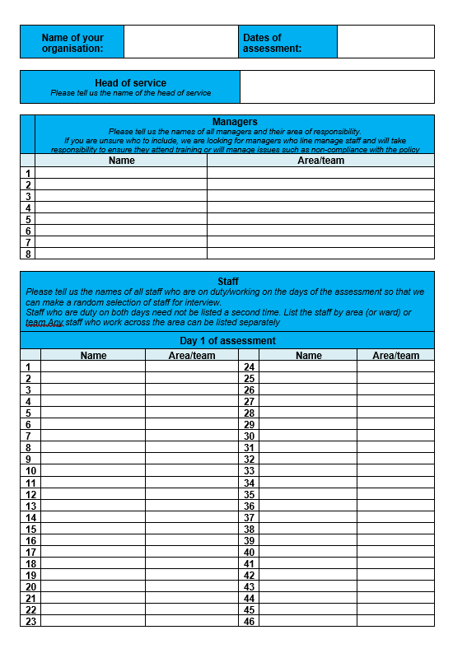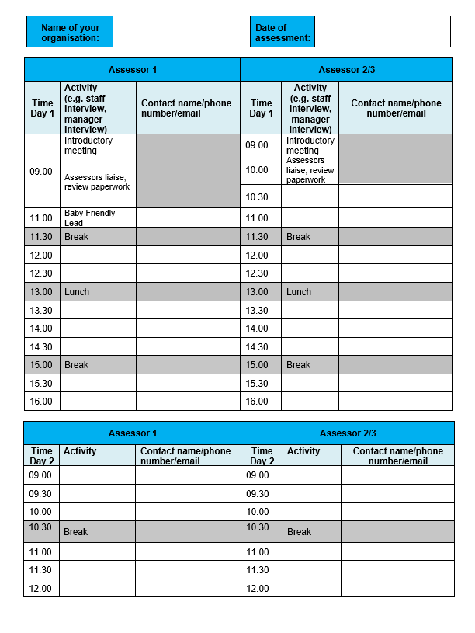
Sending data such as names and phone numbers should be done securely;
- We strongly recommend you send the files via a secure file sending system and password protect the document. Please avoid sending the lists via email without any encryption.
- You may wish to use the Box upload link to send the file (see guidance below) or your own internal IT department may have a preferred approach or system to use. Allowing plenty of time to research and finalise safe sending of the data will help avoid delay and potential threat to us being able to carry out your assessment effectively.

To send us these files directly, please visit this uploading page on our website
unicef.org.uk/BabyFriendly/Health-Professionals/going-baby-friendly/Health-professionals-contact-us/ and follow the link to the Sharepoint upload page

Before you send us any files, please ensure the file names are clear and concise as to what the file contains. Please ensure your organisation name is specified within the document as well. E.g. “Telephone list – Organisation name” or “Curriculum – Organisation name”.

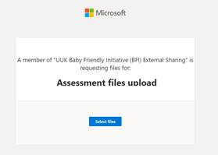
Click ‘select files’ and then choose the file you’d like to send from your computer. You will be prompted to enter your first/last name.
Please then send an email to bfi@unicef.org.uk to confirm how many files you have uploaded to us, so we can confirm receipt of the files.

This will help us identify your files quickly, particularly when we are receiving a large number of files relating to different assessments.

If you have password protected the file, please also call the Baby Friendly office to give the password for the files you’ve sent.

If you have a large number of files to upload and send to us, please contact the office before sending as we may set up a bespoke link for you to use.

Video calls for staff interviews / meetings
Once your lead assessor confirms the interview slots on the timetable, you should set up meeting invites for each slot. Please invite all of the assessment team to each interview slot.
You will need to check what technology you have access to for video calls, for example Microsoft Teams, Skype for Business or Zoom etc. If you have not set up video calls before please ensure you have plenty of time to check with your IT team. It may also be helpful to set up some practice sessions. It is important to ensure that your video link can be accessed externally by the Baby Friendly assessors.

Please ensure that the following are submitted in advance of the assessment: available at the beginning of the assessment:
- A copy of the policy.
- A copy of the curricula for staff training and an outline of the induction programme for new staff.
We will ask to review the database of staff training, this can be done during the assessment via a shared screen:
- Records of staff orientation to the policy
- Records of staff attendance at the various elements of the training programme.
4 Use the checklist on the Stage 2 application form to help track the documentation required

What happens after the assessment
Feedback of findings
You will be informed of the results of the assessment at a video feedback meeting towards the end of the assessment.
We request that you consider carefully who is invited to attend this meeting. We suggest that this is limited to the Baby Friendly lead/s, line manager and other managers with involvement in implementing the standards together with the head of service. This meeting is an opportunity to discuss and plan how any shortfalls can be addressed in order that this assessment is passed or to consider how progress can be made towards the next assessment/reassessment.
Confirmation of the outcome of the assessment
After the assessment, the results will be written up in a detailed report. A copy of this report will be sent to the Baby Friendly Initiative’s Designation Committee, which has to approve the report. They will normally do this within ten days of receiving it and you will then receive a copy of the report and any requirements suggested by the Committee via email. Occasionally, the report has to be considered at one of the Committee’s meetings, which take place every two months. In this case you will need to wait a little longer for confirmation of the result of the assessment.
Although standards assessed on the basis of the information provided at Stage 1 will not be formally re-assessed at Stage 2, the assessors will comment at this visit on anything they notice which conflicts with the information provided previously. They will then include recommendations for addressing these anomalies in their Stage 2 report.
If Stage 2 is deemed passed, you will have 12 months in which to prepare for Stage 3. If Stage 2 has not been achieved, up to 6 months may be allowed (at the discretion of the Baby Friendly Initiative) to enable you to repeat the parts of the assessment which have not been achieved, or to submit additional evidence related to the unmet standards.

1 Stage 2 application form
To download, please visit unicef.org.uk/babyfriendly/stage2

