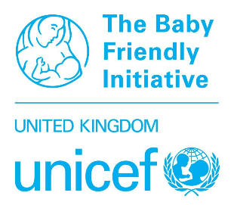
UK Committee for UNICEF (UNICEF UK)
Baby Friendly Initiative
2026 Virtual Annual Conference
18-19 November 2026
Please complete this form and return by email only to bfi@unicef.org.uk
For queries, please contact us on 020 7375 6144 or the above email address.
The email address provided below will be used for the confirmation email and to login to the event
Contact details
Please complete one form per person.
Name:
Job title:
Organisation:
Telephone:
Email:
Payment
Standard Price: £125 per person.
For groups of 5 or more, please complete the Group Booking spreadsheet instead of this form.

Total payment: £

Payment method:
- Invoice / Banked funds (please delete as applicable)
- For payment by invoice, please send a copy of a Purchase Order from your organisation. Your booking will not be fully confirmed until we receive a copy of PO
- For payment with banked funds already paid to UNICEF UK, please provide organisation name/reference code here:
- For card payment, instead of completing this form, book and pay online via Eventbrite here: Baby Friendly Initiative Virtual Conference 2026

- Booking closes at 5pm on Wednesday 11th November.
- We will confirm your booking by email to the address provided above.
- Cancellations will only be considered in writing and must be received by Wednesday 28th October - an administration fee of £5 may be charged. No refund will be given after this date.
- Substitutions: To change the delegate attending, please email with the booking reference and new delegate details by 5pm on Wednesday 11th November.
- The Baby Friendly Initiative is a programme of the UK Committee for UNICEF UK. Registered Charity no. 1072612 (England and Wales), SC043677 (Scotland).
- We care about keeping your data safe; for more information about UNICEF UK’s privacy policy please visit https://www.unicef.org.uk/legal/cookies-and-privacy-policy/

