Instructions on completing this template
- You can view your data on the top left of the Microsoft Forms screen here:
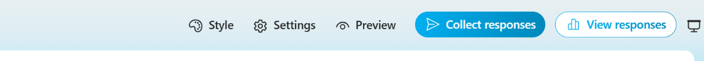

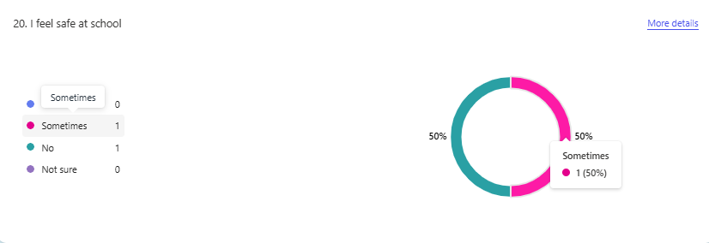
- To complete this findings template, hover the mouse over each segment of the pie chart and record the figures in percentages (%).

- Please return these figures (in %) to your Professional Adviser by filling in the information on the following pages, with your Bronze, Silver, or Gold accreditation paperwork.

Overview
School Name: ____________________________________________
Number of pupils completing questionnaire: _________________
Number of staff completing questionnaire: ___________________

Pupil questionnaire findings
PLEASE COMPLETE IN PERCENTAGES (%) | % of pupils
 | Yes | Sometimes | No | I’m not sure
- I know about my rights as a child
At school,
- I feel safe
- I feel like I belong
- I feel valued for who I am
- Adults treat me with respect (Secondary School)/ I like the way adults treat me (Primary & All-through School)
- Other pupils treat me with respect (Secondary School)/ Other pupils are kind and helpful (Primary & All-through School)
- Adults listen to my views
- If I have a concern, I could tell an adult (Secondary School)/ If I have a worry, I could tell an adult (Primary & All-through school)
- My school makes changes based on children’s views
- My school celebrates different backgrounds and cultures
- My individual needs are supported so I can join in at school
- I enjoy being at school
- I feel positive about my learning
- I can make a difference to the rights of others in my local community
- I can make a difference to the rights of others in the wider world
- I have talked about children’s rights with another person outside school in the last three months
- I think everyone should learn about rights

Staff questionnaire findings
PLEASE COMPLETE IN PERCENTAGES (%) | % of staff
 | Strongly Agree | Agree | Disagree | Strongly Disagree | I’m not sure
- Child rights inform the approach I take to my job
- I feel comfortable talking to pupils about their rights
- I understand my role as a duty bearer in school
- Children’s rights make a positive contribution to the ethos and culture of our school
- In general, I have respectful relationships with pupils in the school
- I feel confident to recognise and respond to concerns raised by individual pupils including safeguarding issues
- Children’s rights contribute positively to the way we celebrate and promote diversity and inclusion
- Our school makes changes when needed to ensure that pupils with different needs can participate
- Pupils are actively engaged in their learning
- In general, pupils are actively engaged in the life of the school
- The actions and decisions of adults at school are influenced by pupils’ views
- Adults in the school encourage and support pupils to advocate for children’s rights locally and globally
- In general, I am treated with respect by other adults in the school
- I enjoy working at this school

