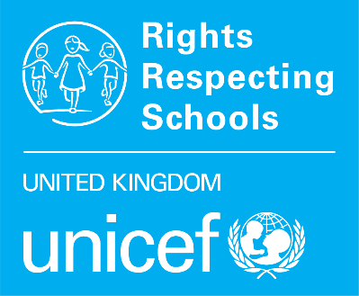
Checklist for
Gold: Rights Respecting
To progress towards Gold: Rights Respecting, your school will build on what you have achieved at Silver: Rights Aware. The efforts to embed child rights in the school will be deeper and wider so that the values and principles of the UNCRC are fully embedded into the whole school’s practice.
For more detailed guidance, forms and documents, please visit our website.
 | Actions | Done
1 | Celebrate achieving Silver: Rights Aware  Inform the whole school community. You can display your Silver logo and certificate, hold an event or assembly, and send out a letter to parents and carers to let them know. Think about sharing your report with your Local Authority and other external partners.
2 | Book Achieving Gold training here
3 | Review your Steering Group  Are this group effectively involved in embedding rights across the school and promoting in the wider community?
4 | Ensure the Award is an ongoing item at staff, council and governor meetings  Adults should know that the Gold Outcome Descriptors are different from the Silver Outcome Descriptors. Use our Spotlight resources to support.
5 | Plan your RRSA journey to Gold with your Steering Group  Prioritise your actions using the Action Plan for Gold, taking into account recommendations from your Silver accreditation visit report.
6 | Book your Gold: Rights Respecting accreditation visit  Download the Gold Accreditation booking form and send it to your Professional Adviser. We recommend booking at least one term in advance.
7 | Complete the School Evaluation: Gold form  Complete the School Evaluation: Gold with support from your Steering Group and colleagues. You may include feedback from staff and pupil questionnaires, reports from your school inspection body, comments from parents, etc.
8 | Identify evidence to meet the Gold Outcome Descriptors  Evidence might include planning, policies, pupils’ work and assemblies so that you have an overview of the learning that is taking place and its impact. Keep the Gold Outcome Descriptors in mind as you produce your evidence PowerPoint.
9 | Measure your progress  Carry out pupil and staff questionnaires to support your evaluation and the growing impact of adopting a child rights approach in school.  Add your findings to your School Evaluation: Gold and upload directly to our portal*.
10 | Upload* your documents at least two weeks prior to your visit.  - School Evaluation: Silver  - Evidence PowerPoint  - Visit Programme

*Six weeks prior to you visit you will receive a link to a secure folder for your Gold documents and log in details for the RRSA portal where you will input your survey data.

