Instructions on completing this template

- You can view your data on the top left of the Microsoft Forms screen here:
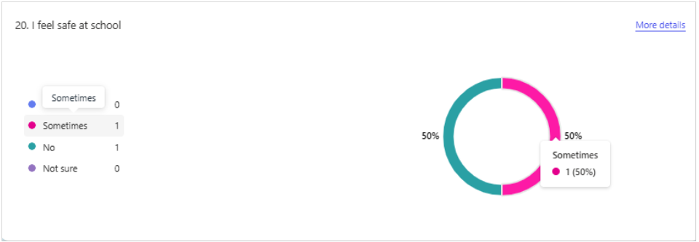

- To complete this findings template, hover the mouse over each segment of the pie chart and record the figures in percentages (%).

- If you have removed any questions of the questionnaire to better suit your pupils’ needs, please leave them BLANK.

- You will then upload your findings using a portal link shared by your Professional Adviser. This will be sent to you approximately 6 weeks prior to your accreditation visit or can be requested when you apply for Bronze.

Overview
School Name: ____________________________________________
Number of pupils completing questionnaire: _________________
Number of staff completing the questionnaire using adult observations: ________________
Pupil questionnaire findings (Accessible Version)
PLEASE COMPLETE IN PERCENTAGES (%) | % of pupils
 | Yes | Sometimes | No | I’m not sure
- I know about my rights as a child
- At school, I feel safe
- At school, I feel like I belong
- At school, I feel valued for who I am
- Adults at school are kind and helpful
- Other pupils at school are kind and helpful
- Adults listen to my views at school
- If I have a worry, I could tell an adult at school
- My school changes things when children express their views
- My school celebrates different backgrounds and cultures
- My individual needs are supported so that I can join in at school
- I enjoy being at school
- I feel good about my learning
- I can make a difference to the rights of others in my local community
- I can make a difference to the rights of others in the wider world
- I have communicated about children’s rights with another person outside school in the last three months
- I think everyone should learn about rights

Pupil Questionnaire Using Adult Observations
PLEASE COMPLETE IN PERCENTAGES (%) | % of pupils
 | Strongly Agree | Agree | Disagree | Strongly Disagree | I’m not sure
- At school, I feel safe
- At school, I feel like I belong
- Adults listen to my views at school
- At school, I feel valued for who I am
- I like the way adults at school treat me
- Other pupils are kind and helpful
- If I have a worry, I could tell an adult at school
- My individual needs are supported so that I can join in at school
- I enjoy being at school
- I feel positive about my learning

Staff questionnaire findings
Number of staff completing questionnaire: ___________________
PLEASE COMPLETE IN PERCENTAGES (%) | % of staff
 | Strongly Agree | Agree | Disagree | Strongly Disagree | I’m not sure
- Child rights inform the approach I take to my job
- I feel comfortable talking to pupils about their rights
- I understand my role as a duty bearer in school
- Children’s rights make a positive contribution to the ethos and culture of our school
- In general, I have respectful relationships with pupils in the school
- I feel confident to recognise and respond to concerns raised by individual pupils including safeguarding issues
- Children’s rights contribute positively to the way we celebrate and promote diversity and inclusion
- Our school makes changes when needed to ensure that pupils with different needs can participate
- Pupils are actively engaged in their learning
- In general, pupils are actively engaged in the life of the school
- The actions and decisions of adults at school are influenced by pupils’ views
- Adults in the school encourage and support pupils to advocate for children’s rights locally and globally
- In general, I am treated with respect by other adults in the school
- I enjoy working at this school

