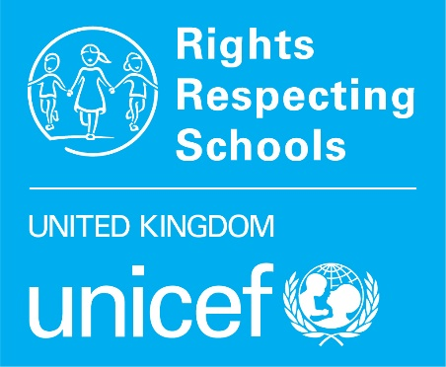
RRSA Bronze application form

There are three parts to this application form. All schools must complete parts one and two. Part 3 is recommended for all schools but is mandatory for schools in London.
PART 1: SCHOOL INFORMATION AND CONFIRMATION OF INITIAL STEPS TAKEN
PART 2: ACTION PLAN FOR SILVER
PART 3: QUESTIONNAIRE FINDINGS FORMS
Please send the completed form to your Professional Adviser. If you are unsure who your Professional Adviser is you can check here.

PART 1 – SCHOOL INFORMATION AND CONFIRMATION OF INITIAL STEPS TAKEN
School name: | Local Authority:
Number of pupils on roll: | Date of submission:
Headteacher name and email address: | RRSA Coordinator name and email address:

Please briefly explain how you have informed the whole school community that the school is working on the RRSA.

Please explain how pupils in your setting are involved in leadership of your RRSA work.

Please briefly explain how you have developed your own knowledge and understanding of rights and RRSA to support you to lead this work in your school. For example, have you attended the Achieving Bronze course, used the e-learning materials, or worked on RRSA in another school?

PART 2: ACTION PLAN FOR SILVER

GUIDANCE
When applying for your Bronze Award and working towards your Silver Accreditation visit, you will be developing and using this Action Plan for Silver as your guide. Below, in the action plan template, you will find questions and prompts to get you thinking about the actions you can do to develop rights respecting practice in your school. These will help you reflect on how your school can become Silver: Rights Aware.
Throughout this form, there are prompts and questions in blue font. These are to help you complete your plan. Please delete the notes as you add your own actions.

PLAN, DO, REVIEW
- With pupils and staff review your school practice against the Silver Outcome Descriptors as outlined below. This will help you to get a range of views on strengths and areas for development.
- RAG rate each descriptor:
RAG Rating | Evidence | Action
Red | Little or no evidence | requires a strong focus
Amber | Some evidence | requires some actions
Green | A lot of evidence | Sustain and develop your current practice ensuring there are clear links to the CRC
- Develop some actions and also note on your plan who is responsible for each action and when this should be done by.
- Remember this is a working document and once you have applied for Bronze it should be regularly reviewed and updated, for example after attending training or during Steering Group meetings. Consider how you will involve children and young people at each stage.
ACTION PLAN FOR SILVER
Please note: We recognise that children and young people’s capacity is age and ability dependent and cannot always be demonstrated, particularly in nursery and additional needs settings. In all contexts the principles of equality, dignity, respect, non-discrimination and participation should be ‘visible around the school’ and be understood and spoken about by adults.

Strand a: Teaching and learning about rights
The United Nations Convention on the Rights of the Child (CRC) is made known to children, young people and adults who use this shared understanding to work for improved child well-being, school improvement, global justice and sustainable living.

outcome | At silver | RAG |  | Actions – WHAT, who, when
- Children, young people and the wider school community know about and understand the United Nations Convention on the Rights of the Child and can share how it impacts on their lives and on the lives of children everywhere. | Many children and young people are familiar with a number of Articles of the CRC and can communicate the rights they enjoy. |  |  | How do you plan to support children and young people to learn about CRC articles?  How could you develop your physical school environment to promote children’s rights?  How will you make links to rights explicit across your curriculum?  Useful resources: Article of the Week, CRC summary, CRC icons
 | Many children and young people know rights are universal and unconditional; the CRC applies to all children and young people everywhere, all the time. |  |  | What do you need to do to support children to understand the concepts of rights being universal and unconditional?  Useful resources: ABCDE of Rights, Rights Around the World
 | Many children and young people demonstrate an awareness of where and why some children may not be able to access their rights. |  |  | How can you increase children and young people’s engagement in learning about local and global issues that link to rights?  Do you engage with age-appropriate current affairs to support knowledge of global issues and make links to rights?  Useful resources: Rights Around the World, World’s Largest Lesson
 | Adults and the wider school community know about and understand the CRC. |  |  | Staff – How do you plan to support all members of staff to develop knowledge and understanding of the CRC and RRSA?  Governors/Parent Council – How will you support governors/parent councillors to develop knowledge and understanding of the CRC and RRSA?  Parents – What are the communication methods you have in place that will support informing parents about your work on the CRC?  Useful resources: Informing your school community, RRSA Spotlight

strand b: Teaching and learning through rights – ethos and relationships
Actions and decisions affecting children are rooted, reviewed and resolved through rights. Children, young people and adults collaborate to develop and maintain a school community based on equality, dignity, respect, non-discrimination and participation; this includes learning and teaching in a way that respects the rights of both educators and learners and promotes well-being.

outcome | At silver |  | RAG |  | Actions – WHAT, who, when
- In school children and young people enjoy the rights enshrined in the United Nations Convention on the Rights of the Child. | Many children and young people know and understand how school facilitates them to enjoy a range of their rights. |  |  |  | What will you do to ensure that children understand which rights are most relevant to school life and how the adults in school ensure that these rights are respected for all children?
 | Many children, young people and adults share how they and others act to create a rights respecting environment. |  |  |  | How can you ensure that all members of the school community understand their role in relation to creating a rights respecting environment?
- Relationships are positive and founded on dignity and a mutual respect for rights | Many children and young people can communicate about how positive relationships are encouraged. |  |  |  | What will you do to support increasing numbers of children and young people to develop positive relationships with their peers and with adults through rights and respect?  Useful resource: Charter guidance
 | Rights are used to explore moral dilemmas and rights respecting approaches are developed. |  |  |  | How can you encourage teachers to use the language of rights and respect when discussing controversial or complex real-life scenarios?
- Children and young people are safe and protected and know what to do if they need support. | Many children and young people share that they feel in a safe environment at school and can demonstrate how their actions and those of others contribute to this. |  |  |  | What do you have in place already to regularly monitor how safe your pupils feel in school and online?  What can you put in place to build understanding of safeguarding work and its link to children’s rights so that all members of the school community understand this link?
 | Many children can show what they would do / who they would speak to if, for any reason, they did not feel safe. |  |  |  | What will you do to ensure that children understand the school’s mechanisms for keeping them safe, and the links with Article 12 and Article 13?
- Children’s social and emotional wellbeing is a priority. They learn to develop healthy lifestyles. | Many children and young people know how the school supports them with their physical and mental health, social and emotional needs. |  |  |  | How can you strengthen your work to ensure that children’s social and emotional wellbeing is a priority?
 |  |  |  |  | How will you make the link between the work your school does to support children to develop healthy lifestyles and relevant CRC articles?
- Children and young people are included and are valued as individuals. | Many children and young people can share how they are included and valued at school and understand how their actions and those of others contribute to this. |  |  |  | What can you develop to ensure that Article 2, non-discrimination, is understood and experienced by all members of the school community?
- Children and young people value education and are involved in making decisions about their education. | Many children and young people are positive about their school and their learning. |  |  |  | How can you ensure that children respect their own and others’ right to an education and engage positively with their learning?  What can you do to encourage children and young people to play a more active role in their own learning and shaping the curriculum? Consider the links between Article 12 and 28/29.  Useful resource: Guide to a Rights Respecting Classroom
 | Many children understand and can communicate about the role they play in their learning.
 | Many adults explain how rights respecting language shapes a positive learning environment.

Strand c: Teaching and learning for rights – participation, empowerment and action
Children are empowered to enjoy and exercise their rights and to promote the rights of others locally and globally. Duty bearers are accountable for ensuring that children experience their rights.

outcome | At silver | RAG | Actions – WHAT, who, when
- Children and young people know that their views are taken seriously. | Many children, young people and adults know how young people can express their opinions and have been involved in decisions about their life in school. |  | What do you need to do to ensure the school provides opportunities for children and young people to be meaningfully involved in decision-making and support them to undertake leadership roles in certain areas? How will you link this with Article 12 and 13?  How can you check that children know the impact of their involvement?  How can you strengthen and increase opportunities for all children to share ideas about school improvement?  Useful resource: Steering Group Guidance
- Children and young people have taken action to claim their rights and promote the rights of others, locally and globally. | Many children and young people have been involved in a range of activities to promote children and young people’s rights on a local and global scale. |  | How do you plan to ensure that children have opportunities to participate in a range of activities which promote the rights of others?  How can you link your existing fundraising to rights?  Useful resource: A guide to Global Citizenship, Right’s Around the World

Part 3 – Questionnaires Findings Forms

Find full questionnaire guidance here.

INSTRUCTIONS ON COMPLETING THIS TEMPLATE
- You can view your data on the top left of the Microsoft Forms screen here:
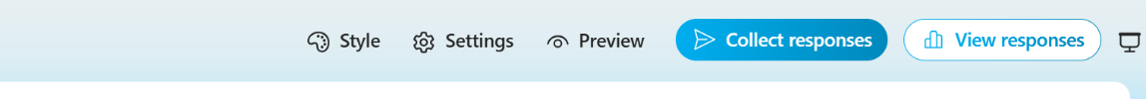

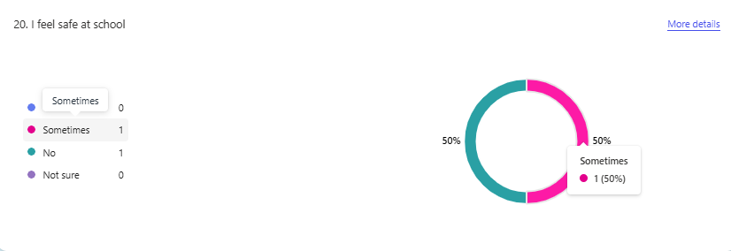
- To complete this findings template, hover the mouse over each segment of the pie chart and record the figures in percentages (%).

- Please return these figures (in %) to your Professional Adviser by filling in the information on the following pages.

Pupil questionnaire findings (compulsory for London)
Number of pupils completing questionnaire: _________________
Number of staff completing questionnaire: ___________________
PLEASE COMPLETE IN PERCENTAGES (%) | % of pupils
 | Yes | Sometimes | No | I’m not sure
- I know about my rights as a child
At school,
- I feel safe
- I feel like I belong
- I feel valued for who I am
- Adults treat me with respect (Secondary School)/ I like the way adults treat me (Primary & All-through School)
- Other pupils treat me with respect (Secondary School)/ Other pupils are kind and helpful (Primary & All-through School)
- Adults listen to my views
- If I have a concern, I could tell an adult (Secondary School)/ If I have a worry, I could tell an adult (Primary & All-through school)
- My school makes changes based on children’s views
- My school celebrates different backgrounds and cultures
- My individual needs are supported so I can join in at school
- I enjoy being at school
- I feel positive about my learning
- I can make a difference to the rights of others in my local community
- I can make a difference to the rights of others in the wider world
- I have talked about children’s rights with another person outside school in the last three months
- I think everyone should learn about rights

Staff questionnaire findings (compulsory for London)
PLEASE COMPLETE IN PERCENTAGES (%) | % of staff
 | Strongly Agree | Agree | Disagree | Strongly Disagree | I’m not sure
- Child rights inform the approach I take to my job
- I feel comfortable talking to pupils about their rights
- I understand my role as a duty bearer in school
- Children’s rights make a positive contribution to the ethos and culture of our school
- In general, I have respectful relationships with pupils in the school
- I feel confident to recognise and respond to concerns raised by individual pupils including safeguarding issues
- Children’s rights contribute positively to the way we celebrate and promote diversity and inclusion
- Our school makes changes when needed to ensure that pupils with different needs can participate
- Pupils are actively engaged in their learning
- In general, pupils are actively engaged in the life of the school
- The actions and decisions of adults at school are influenced by pupils’ views
- Adults in the school encourage and support pupils to advocate for children’s rights locally and globally
- In general, I am treated with respect by other adults in the school
- I enjoy working at this school

